Polybase blob to dwh,datamart,fact and dimension table,architecture of dwh

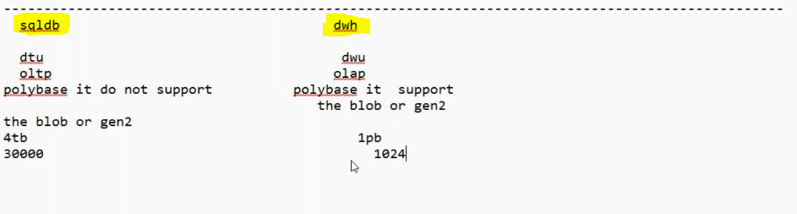

Create blob storage upload any file:
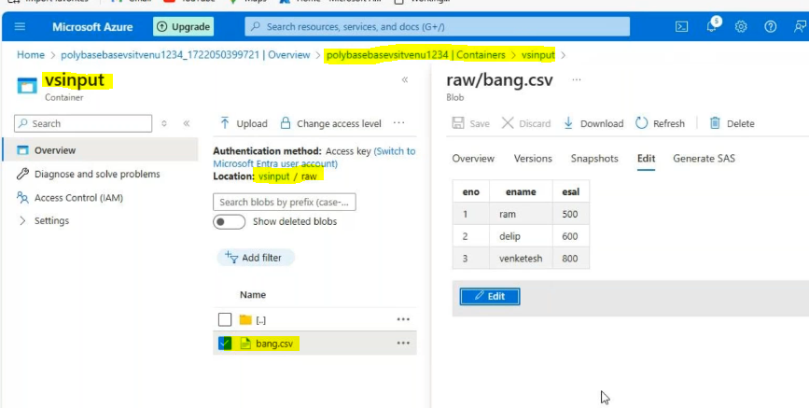
Create dedicated sql pool:
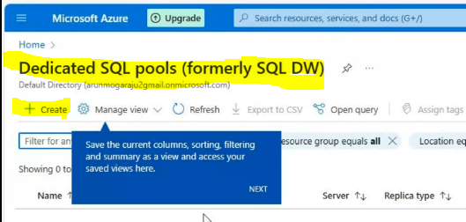
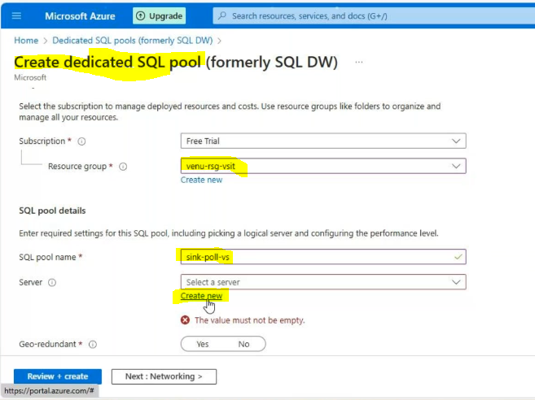
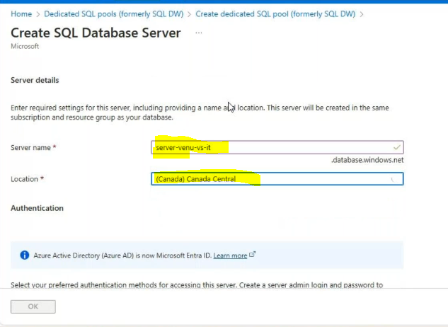
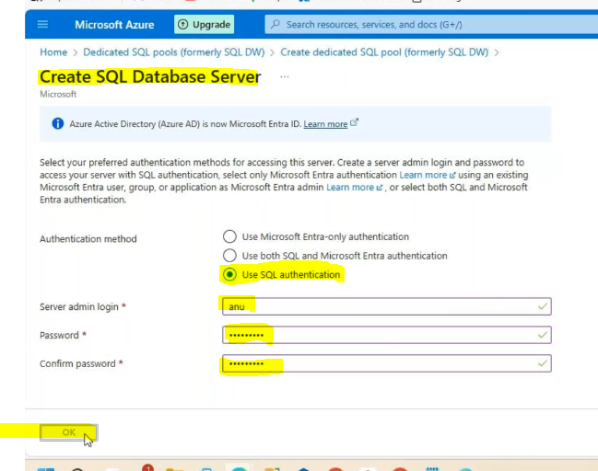

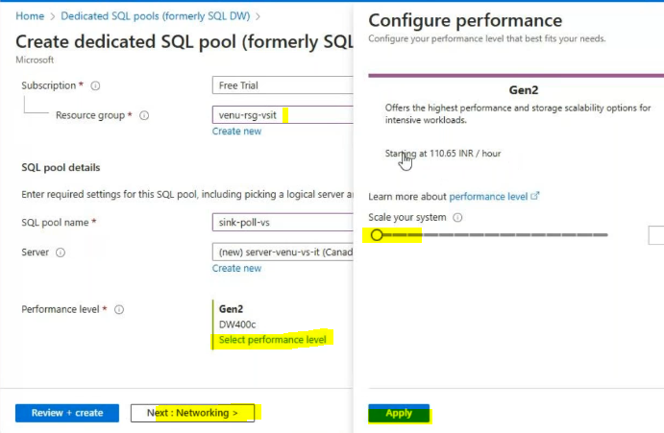

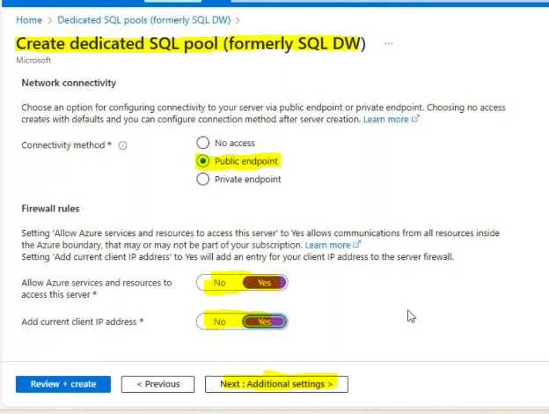
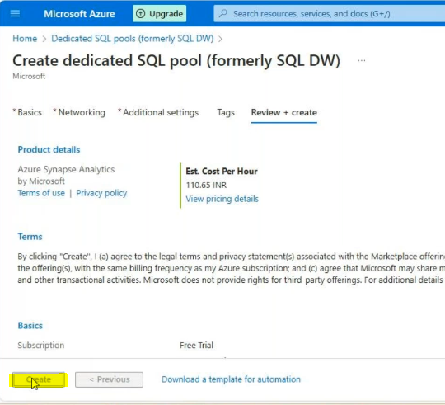
Enable our ipv4 in sql server or database:
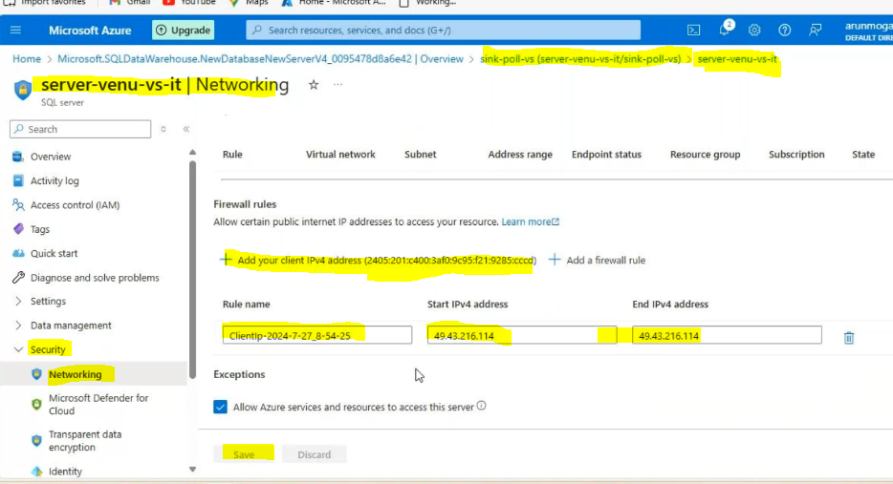
Connect sql database with ssms: Copy the scoped credential
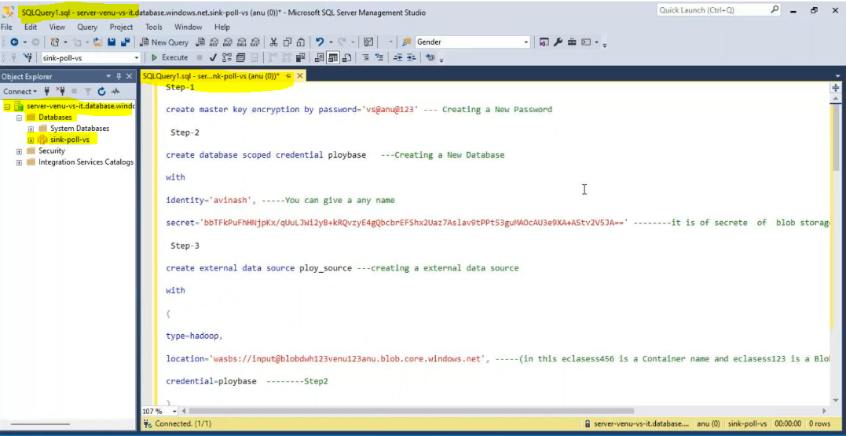

Step-1

create master key encryption by password='vs@anu@123' --- Creating a New Password

Step-2

create database scoped credential ploybase ---Creating a New Database

with

identity='avinash', -----You can give a any name

secret='bbTFkPuFhHNjpKx/qUuLJWi2yB+kRQvzyE4gQbcbrEFShx2Uaz7Aslav9tPPt53guMAOcAU3e9XA+AStv2V5JA==' --------it is of secrete of blob storage available in the ACCESS KEY

Step-3

create external data source ploy_source ---creating a external data source

with

(

type=hadoop,

location='wasbs://input@blobdwh123venu123anu.blob.core.windows.net', -----(in this eclasess456 is a Container name and eclasess123 is a Blob storage name)

credential=ploybase --------Step2

)

Step-4

create external file format file1 -- creating a external format

with(

format_type=delimitedtext,

format_options(field_terminator=',',first_row=2))

Step-5

create external table product1

(

eno int,

ename varchar(10),

esal varchar(10))

with(

data_source=ploy_source, ---Step3

file_format=file1,---------step4

location='/2023/')-----Foldername

select * from product1

Step-6

CREATE TABLE [dbo].[DimProduct]

WITH (DISTRIBUTION = HASH([eno] ) ) ------Distribution method above 2gb

AS SELECT * FROM [dbo].[product1] ;

CREATE TABLE [dbo].[DimProduct1]

WITH (DISTRIBUTION = Round_robin ) ------Distribution method below 2 gb

AS SELECT * FROM [dbo].[product1] ;

CREATE TABLE [dbo].[DimProduct2]

WITH (DISTRIBUTION = REPLICATE ) ------Distribution method less than 500 rows or 10 mb

AS SELECT * FROM [dbo].[product1] ;

Result:
